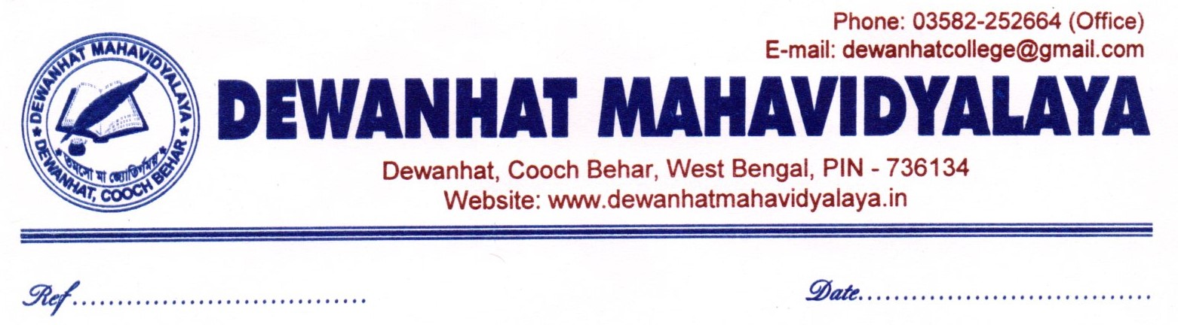
NOTICE
Date: 19.06.2026
This is to inform all teaching and non-teaching staff of Dewanhat Mahavidyalaya that an online seminar will be organized on the occasion of Paschimbanga Divas (West Bengal Day) on 20 June 2026 at 8:30 p.m.
The seminar will be organized by the Department of History with the objective of commemorating and reflecting upon the rich historical, cultural, and intellectual heritage of West Bengal.
Seminar Topic: The Historical Legacy of Bengal and Its Contemporary Relevance
Speaker: Shri Swadhin Jha
The webinar link and other necessary details will be communicated in due course.
All teaching and non-teaching staff members are requested to attend the seminar and contribute to the successful observance of Paschimbanga Divas.

_______________________
Dr Aziz Ahmed
Principal
Dewanhat Mahavidyalaya
Cooch Behar
In communication to:
- Teachers' Common Room
- Office Notice Board
- College Website
- Official WhatsApp Groups of Teaching and Non-Teaching Staff

